 | Monday | Tuesday | Wednesday | Thursday | Friday | Shabbos | Sunday
Morning Routine
Clean Up
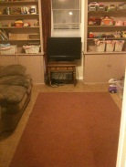
Nighttime Routine
Go Straight
To Sleep

